REMOTE APP

# AIM

TO CREEATE A REMOTE APP

# PROCEDURE

* Create a wireframe according to the mobile application
* Select the basic theme for page to be created
* Use different shapes to create layout as menu icons
* Use assessts options to get different components to implement
* Give various options to operate
* Give various advantages to select this

# IMAGE

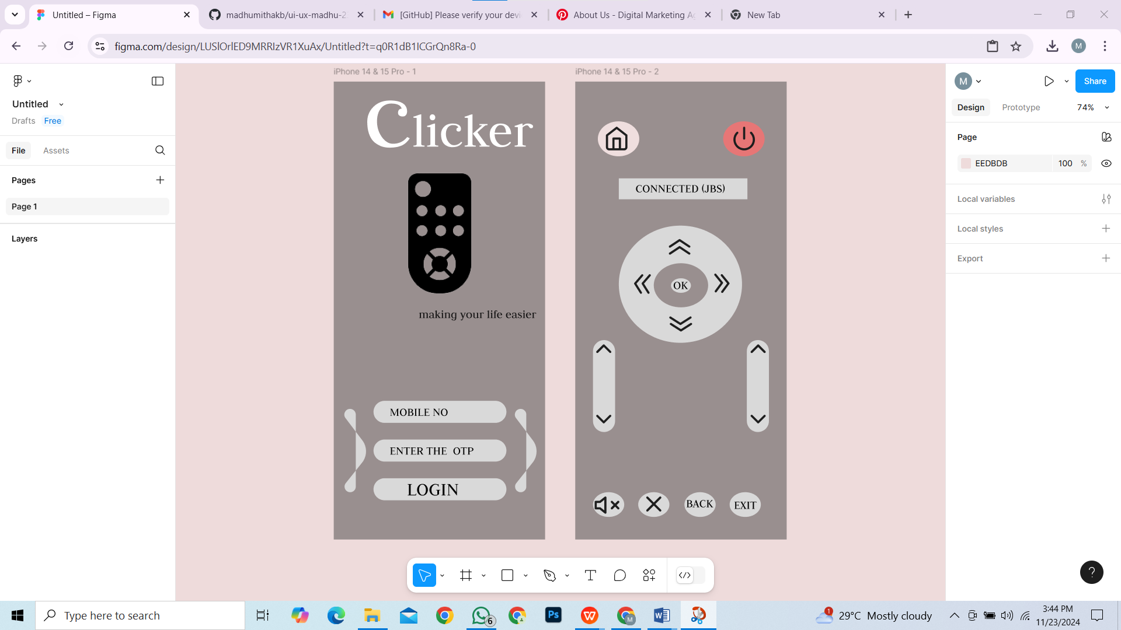

# RESULT

REMOTE APP IS DESIGNED